UI/UX Design Document

PeerGrid

A Student-Focused College Discovery & Community Platform

Interactive Prototype:
https://www.figma.com/design/fUy1TXeqnOvR0UUXzGlt4P/PeerGrid?node-id=0-1&t=kfzBFOLBfq6h9R2u-1

Introduction
PeerGrid is a student-focused platform designed to help users discover and explore colleges, view college-related events and activities, connect with the student community, and access college reviews and ratings. The UI/UX design aims to provide a simple, organized, and user-friendly experience.

UI/UX Design Objectives
- To create a simple and attractive interface.
- To provide easy navigation between application features.
- To help users discover and explore colleges.
- To provide information about college events and activities.
- To encourage interaction through the community feature.
- To allow users to view and share college reviews.
- To maintain a consistent design throughout the application.

Target Users
- Students searching for colleges
- School students planning higher education
- College students
- Students interested in college events
- Students who want to share their college experiences
- Users who want to view college ratings and reviews

Design Tool Used
The PeerGrid user interface was designed using Figma. The tool was used to create the screen layouts, organize interface components, select colors and typography, and design the overall user experience. The interactive prototype can be viewed here: PeerGrid Figma Prototype.

Design Style
- Blue-based color theme
- Clean and minimal layout
- Simple and readable typography
- Consistent icons
- Card-based design
- Easy navigation
- Student-friendly interface

User Interface Designs

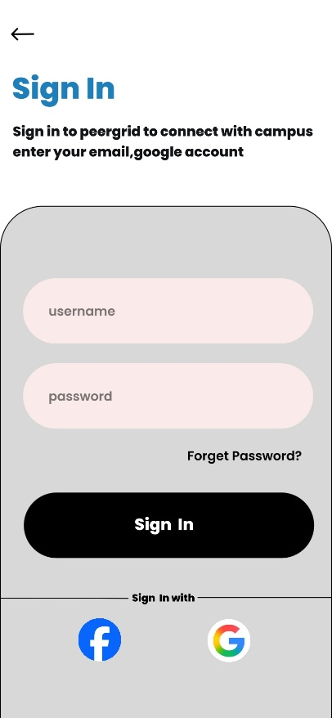
Login Screen
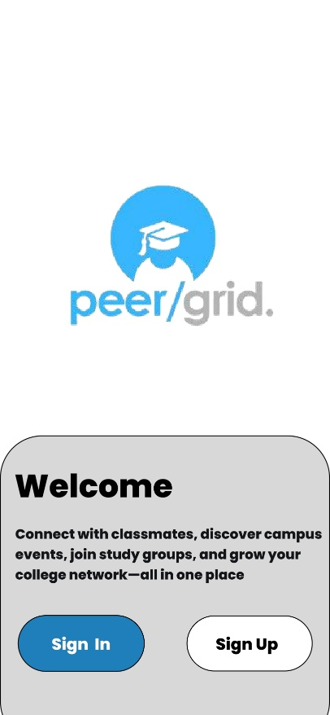
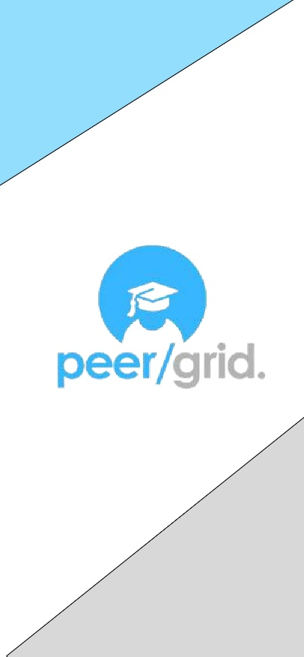

Figure 1: PeerGrid Login Screen

Description
The Login Screen allows existing users to access their PeerGrid accounts. Users can enter their email address or username and password to log in. The interface also provides options for password recovery, Google sign-in, Microsoft sign-in, and new-user registration.

Main Components
    - PeerGrid logo
    - Welcome message ("Welcome ")
    - Email or username field
    - Password field with visibility toggle icon
    - Forgot Password option
    - Login button
    - Google sign-in
    - Sign-up option

Home Screen
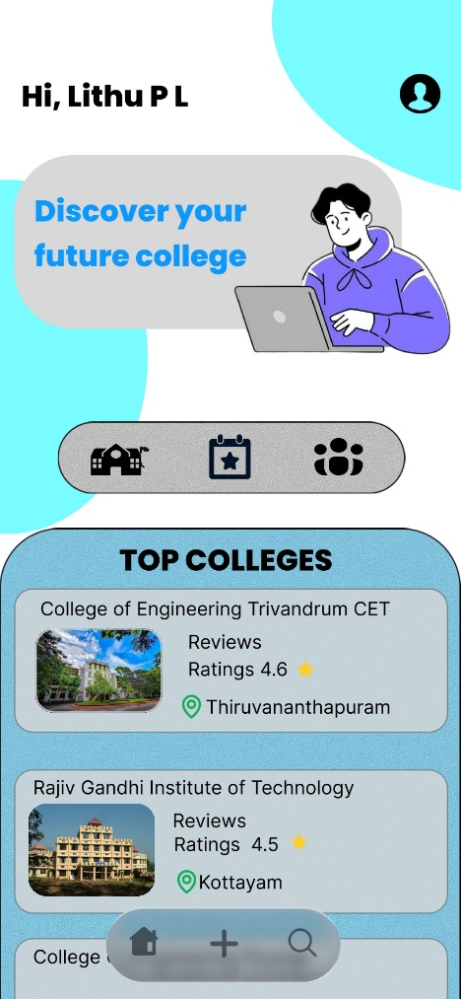
Figure 2: PeerGrid Home Screen

Description
The Home Screen acts as the main dashboard of PeerGrid. It provides access to the three major categories: Colleges, Events, Community. It also includes a top-college recommendations, notifications, user-profile access, and bottom navigation.

Main Components
    - Greeting message ("Hii, lithu pl !")
    - Profile icon
    - Discover - Explore - Rate banner
    - Categories section (Colleges, Events, Community)
    - Top Colleges section
    - College cards with image, name, ratings, and location
    - Bottom navigation bar

Colleges predict system
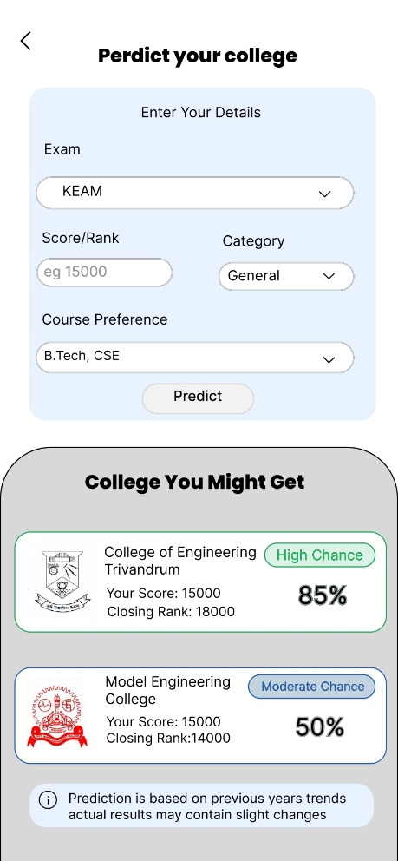
Figure 3: PeerGrid College predict Interface – Predict Your College

Description
including a College Predictor tool. Users can enter their exam, score or rank, category, and course preference to generate a personalized list of colleges they are likely to get admission into, along with an estimated admission chance for each.

Main Components
    - Page title: Predict Your College
    - Info icon for guidance
    - Exam selection dropdown (e.g. KEAM)
    - Score / Rank input field
    - Category dropdown (e.g. General)
    - Course preference dropdown (e.g. B.Tech, CSE)
    - Predict button
    - "Colleges You Might Get" results section
    - College cards with logo, name, closing rank, chance label (High / Moderate Chance), and match percentage
    - Disclaimer note on prediction accuracy

User Flow
Home Screen → Discover College → Enter Exam Details → View Predicted College List

Events Category Interface
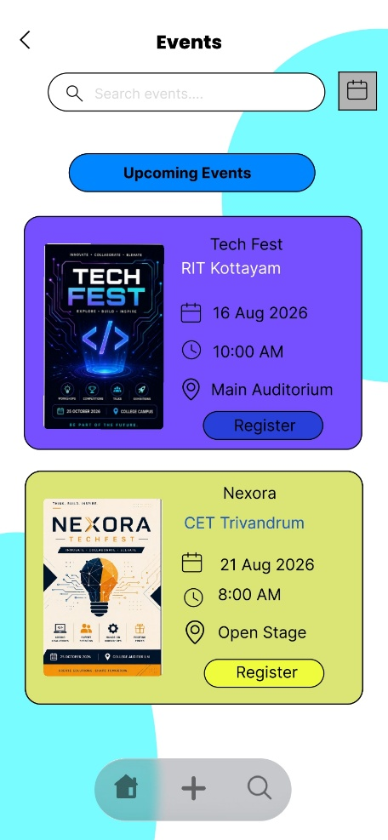
Figure 4: PeerGrid Events Interface

Description
The Events Interface allows users to discover college events and activities. Users can browse available events and view information such as the event name, date, time, location, and organizing college.

Main Components
    - Page title: Events
    - Search bar ("Search events. ")
    - Calendar view icon
    - Filter tabs: Upcoming, Today, This Week
    - Upcoming Events section
    - Event cards with poster image, event name, organizing college, date, time, and location
    - Register button on each event card

User Flow
Home Screen → Events Category → Event List → Register for Event

Community Category Interface

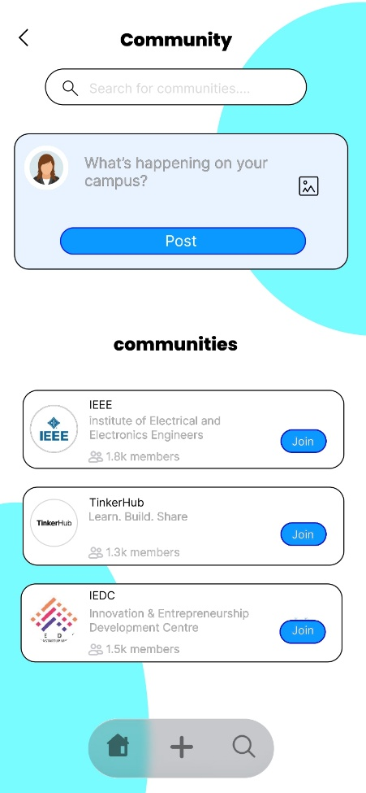
Figure 5: PeerGrid Community Interface

Description
The Community Interface provides a space where students can interact, share information, ask questions, and participate in discussions related to colleges and student life.

Main Components
    - Page title: Community
    - Post creation box ("What's happening on your campus?") with image attachment icon
    - Post button
    - Category filter tabs: All, Campus Life, Events, Questions
    - Post cards with user profile image, username, timestamp, college name, and content
    - Like, Comment, and Share options on each post

User Flow
Home Screen → Community Category → View Posts → Interact or Create a Post

College Interface

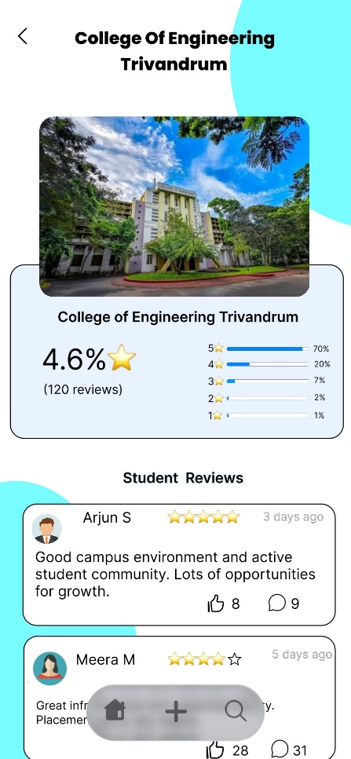
Figure 6: PeerGrid Reviews Interface

Description
Users can search for a college, read existing reviews, and see an overall rating breakdown by star count.

Main Components
    - Page title: Reviews
    - College name and image
    - Overall rating percentage and star rating
    - Total review count
    - Star-by-star rating distribution bars (5-star to 1-star)
    - Student Reviews section
    - Reviewer name, star rating, timestamp, and review text
    - Like and comment counts on each review

User Flow
Home Screen → College Category → Select College → View Reviews

Navigation Structure
Login / Sign Up → Home Screen → Colleges | Events | Community → Detailed Information and User Interaction
The Home Screen acts as the central navigation point of the application. Users can access the Colleges, Events, Community, and Reviews sections through the category icons. Each category provides additional information and user-interaction features.

Overall User Flow
Open PeerGrid → Login or Sign Up → Home Screen → Select a Category

Then:
- Colleges → Enter Details → View Predicted Colleges
- Events → Browse Events → View Event Details / Register
- Community → View Posts → Interact or Create a Post

UI/UX Design Principles

Consistency
Similar colors, fonts, icons, spacing, and layouts are used throughout the application.

Simplicity
The interface is designed to avoid unnecessary complexity and make important features easy to access.

Easy Navigation
Category icons and the bottom navigation bar allow users to move between different sections easily.

Visual Hierarchy
Important information is displayed prominently using suitable text sizes, spacing, cards, and visual elements.

Readability
Clear fonts, proper spacing, and organized content improve the readability of the application.

Conclusion
The PeerGrid UI/UX design provides a simple, organized, and student-friendly interface. The application includes a Login Screen, Home Screen, and dedicated interfaces for Colleges, Events, Community, and Reviews. These interfaces allow users to discover colleges, explore events, interact with other students, and access college reviews. The design provides a consistent visual style and supports easy navigation throughout the application.

